MED D – Filenet

Details
Logging in to Filenet
Searching for a Beneficiary’s Document(s) in Filenet
Opening and Manipulating a Document in Filenet
Related Documents

Description: This document provides the MED D Customer Care Representative (CCR) details and instructions to access and search the Filenet database.

Details
Filenet is a tool CCRs use to view inbound and outbound (faxed or mailed) correspondence from and to MED D beneficiaries.
- Beneficiary checks and coupons received by the plan are stored in Filenet.
- Letters to beneficiaries are stored in one of two places:
  - Filenet
  - ONEclick
- All MED D Premium Billing Invoices are stored in ONEclick, refer to Med D – Viewing Correspondence in PeopleSafe.

Note: Letters that are not in reference to Premium Billing will be stored in either Filenet or ONEclick per the business owner’s request. The CCR should review each database when addressing issues unrelated to Premium Billing.

Top of the Document

Logging in to Filenet
In order to Log in to the Filenet database, the CCR will:

Step | Action
1 | Click on the Filenet hyperlink to open the Filenet tool: https://fnopenclient.caremarkrx.net/FNOpenClient/  Note: This URL can be saved to the CCR’s internet favorites.
2 | Click the MedD Production radio button and then click the Log In hyperlink above it in the Filenet tool bar:  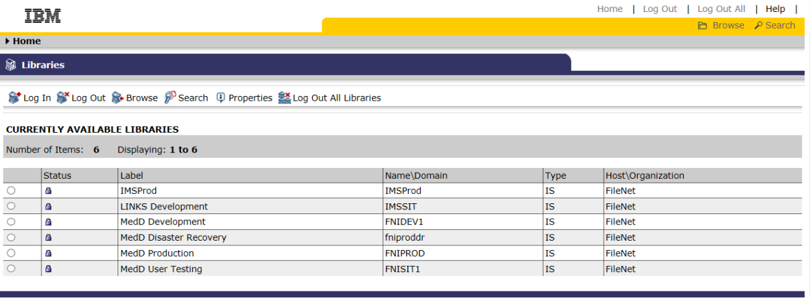  Result: The Filenet Log In screen will display.
3 | Enter the valid User Name and Password provided by the Supervisor or Administrator and then click on the Log In button.  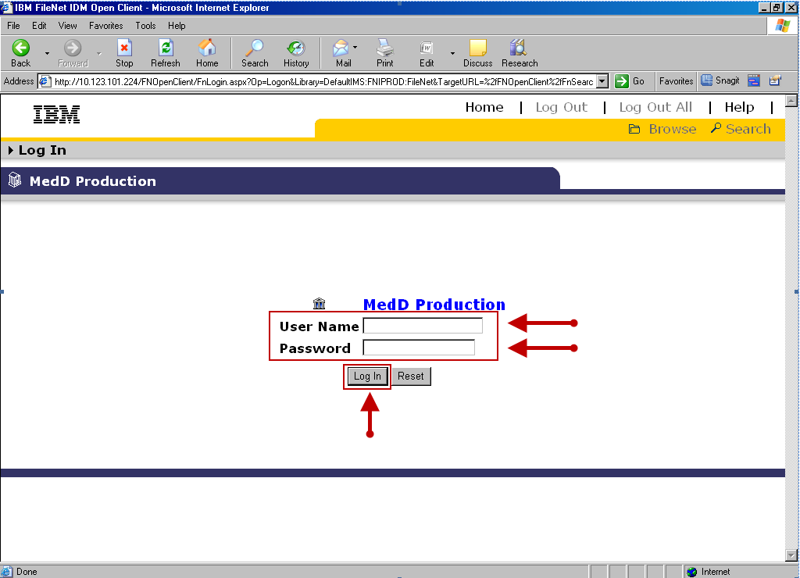  Result: The Search Template for MedD Production page will display.  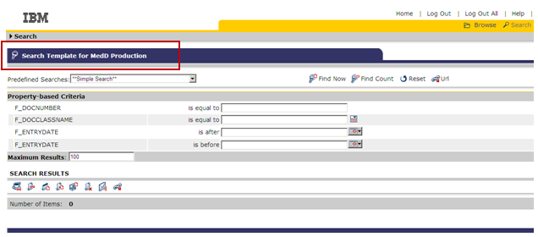

Top of the Document

Searching for a Beneficiary’s Document(s) in Filenet

In order to search for documents sent by the beneficiary, the CCR will:
Step | Action
1 | Select MPD Member from the Predefined Searches drop-down menu, in order to access the beneficiary’s account and view ALL documents (sent or received).  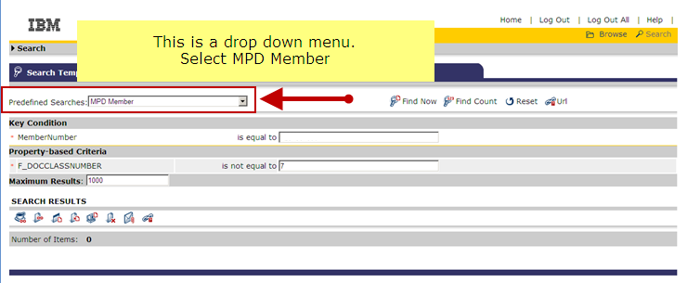
2 | Enter the appropriate ID number in the “is equal to” field for the document type being searched for:  - External ID (Member ID): Returns current premium billing invoices and Dunning letters  - Subscriber ID: Returns all historical premium billing invoices (prior to July 2015)  Notes:  - Search by both ID types if you are not able to locate the invoice requested.  - The ID number is case sensitive and must be entered in CAPITAL LETTERS.  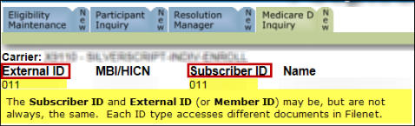  Reminder: The Subscriber ID and External ID are listed in PeopleSafe, under the Medicare D Inquiry tab at the top of the Participant Details screen.
3 | Click on the Find Now hyperlink.  Result: A list of documents sent to the beneficiary will appear at the bottom of the screen.
4 | Sort the results list to find the document in question using any of the categories at the top of the section.  - Key search categories include:  - Corr_Doc_Type: Indicates the type of document (for example a letter or invoice)  - Scan Date: Indicates how recently the document was scanned to Filenet and, by extension, mailed to the beneficiary.  Note: If more than 10 images are available, results will be listed on multiple pages.  - Click on the page number indicated to the far right of the screen to view an additional page of images.  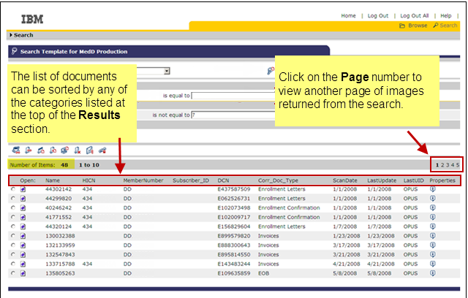  Note: MBI data is not stored within Filenet.

Top of the Document

Opening and Manipulating a Document in Filenet

In order to Open and/or manipulate a document sent by the beneficiary, the CCR will:
Step | Action
1 | There are three ways in which a CCR can view a document.  - Coffee Cup Java View Option    Note: If this option is not allowing the CCR to view the image, it may be necessary for the CCR to have their Java Version updates to Java v1.6.023. The CCR will contact Frontline Services (FLS) in order to open a ticket and have the Java version updated.  - FileNet Icon    - Open View    Click on the radio button to the left of the desired document and then click on one of the three options in order to view the image.  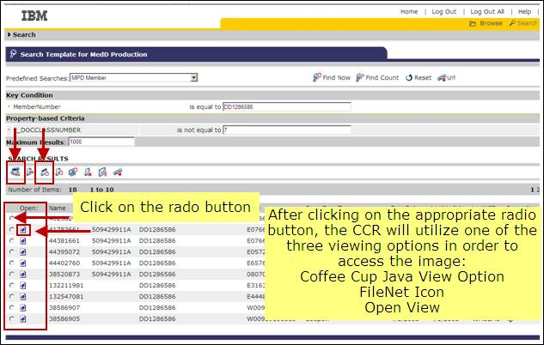  Result: A New window will open with an image of the document.  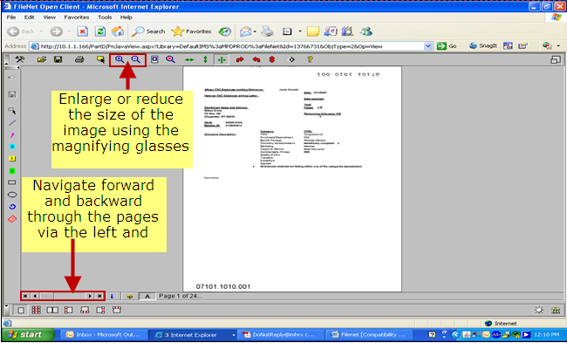  If the user has Annotation Privileges, the Annotations Toolbar will be displayed.  Reminder: If annotations are used, the image must be saved before exiting by clicking on the disk icon on the Annotations Toolbar.  Annotation Privileges such as:  - Adding text notes  - Sticky notes  - Other visual information to the image

Top of the Document

Related Documents
Parent Document: CALL-0048: Medicare Part D Customer Care Call Center Requirements-CVS Caremark Part D Services, L.L.C.
Abbreviations/Definitions: Abbreviations & Definitions
Top of the Document

Not to Be Reproduced or Disclosed to Others without Prior Written Approval
ELECTRONIC DATA = OFFICIAL VERSION – PAPER COPY = INFORMATIONAL ONLY

